### **CSE211 Web programming, Fall Semester 24/25**

**Assignment #1: Websites conceptual Design and mock-up**

**Ramy Sameh Louis 222100551**

### **Research:**

### **Introduction**

The evolution of the Web has dramatically transformed the way people communicate, companies do business, and information is disseminated. The movement from Web 2.0 to Web 4.0 represents a next major leap from mere social interactivity to a new dimension, with a highlighting of semantic understanding and artificial intelligence. At every step of the Web, capability has been added, bringing deeper impacts on business and personal communications, a journey that is now taking us to intelligent and adaptive networks.

1. **Characteristics of Web 2.0, Web 3.0, and Web 4.0**

**Web 2.0**, in many cases called the "social web," is characterized by user-generated content, ease of communication, interactive, networked platforms. In contrast to the first generation, Web 1.0, which was mainly static, Web 2.0 makes users active participants and sharers of information through, for example, updates on a Facebook page, through a tweet, or posting on YouTube.

**Web 3.0** is a series of extensions to Web 2.0, adding in semantic capabilities. Frequently called the "semantic web," Web 3.0 enables machines to understand data in a meaningful way, allowing for narrower and more tailored content delivery. This is achieved through technologies like RDF (Resource Description Framework) and ontologies that enable knowledge linking using structured data.

**Web 4.0**, also being termed as the "intelligent web," is using AI to anticipate and act upon a user's needs autonomously. Building on the semantic capabilities of Web 3.0, it further integrates AI and machine learning to create responsive, intuitive, and tailored experiences across devices.

### **Key Features of Web 2.0 and Network Empowerment**

The most prominent features of Web 2.0 have been the abilities of the users in creating content, making social networks, and sharing. These abilities empower networks since users are connected with each other and share information globally. In the Web 2.0 platforms, communities and social interactions give rise to virtual networks and collective intelligence. As such, this network effect increases innovation and communication where users get a special platform for self-expression and collaboration.

### **Key Features of Web 3.0 and Knowledge Empowerment**

Web 3.0 introduces advanced data connectivity, which translates to deeper meaning and semantic understanding of information. This version of the web allows computers to "understand" data in context, facilitating intelligent recommendations and tailored content. Technologies that underpin these connections—machine learning, blockchain, and natural language processing—are going to empower users with knowledge-driven tools that tailor themselves to user preferences. This is the semantic layer that will improve the relevance and accuracy of data.

### **Key Features of Web 4.0 and Intelligence Empowerment**

Web 4.0 introduces intelligent connectivity, fusing AI, machine learning, and IoT to give birth to a web that accurately and proactively understands and fulfills the user's needs. Thus, Web 4.0 may optimize user experiences on all connected devices by using adaptive systems and analyzing data in real-time. Such intelligence will permit very responsive and interactive platforms, capable of providing predictive insights in a seamless way, wirelessly across environments.

### **The Role of Collective Intelligence, Social Networking, and Social Media**

Collective intelligence and social networking are today's backbone of the digital ecosystem, where ideas are shared and problems get solved in a collaborative manner. Social media and social bookmarking now constitute important content discovery and information dissemination channels. These platforms aggregate knowledge so that information can be more easily accessed by larger audiences and drive business growth through customer engagement and integrated feedback mechanisms.

### **Empowering Current and Future Business Plans**

Web technology evolution has direct implications for business strategy: Web 2.0 enables customer engagement through social media; Web 3.0 enables personalization; and Web 4.0 introduces predictive analytics and intelligent automation. Those technological developments support data-driven decision-making and help businesses create adaptive, responsive, and user centered services, opening possibilities for further innovations and efficiencies.

### **Application of Latest Technologies in Professional Contexts**

In my professional field, the novelty of Web 4.0 provides tools for predictive analysis and real-time decision-making. Using AI-driven platforms, I would like to use data analytics in understanding consumer preferences, automating mundane tasks, and developing user-centric solutions. Integration of these technologies can result in much efficiency and lead to more informed and effective strategies.

### **Conclusion**

From the transition of Web 2.0 to Web 4.0, the dominant factor is how web technologies can bring an incredible difference in society and business. Each evolution has brought new capabilities for interactivity, data interpretation, and automation features, which ultimately shape the web into a more intuitive, connected, and intelligent environment.

### **References**

[1] T. Berners-Lee, "Web 3.0: The Semantic Web," *Scientific American*, vol. 284, no. 5, pp. 34-43, 2001. [2] G. Vossen, S. Hagemann, *Unleashing Web 2.0: From Concepts to Creativity*, 1st ed., Amsterdam, Netherlands: Elsevier, 2007. [3] D. Allemang, J. Hendler, *Semantic Web for the Working Ontologist*, 2nd ed., Burlington, MA: Morgan Kaufmann, 2011. [4] K. J. Kadhim, “Web 4.0: The Future of Web and Social Media,” *Journal of Technology and Information Systems*, vol. 3, no. 2, pp. 77-88, 2019.

**Website Planning:**

### **1. Define the purpose of your intended website.**

The purpose of the "Clever Kids" website is to provide a fun and engaging online educational platform for children aged 6-12. It aims to offer free resources such as quizzes, games, and videos covering various subjects like math, science, reading, and history, fostering a love for learning in a user-friendly environment.

### **2. What would you like the website to accomplish?**

The website aims to enhance children's learning experiences by making educational content accessible and enjoyable. It seeks to support parents and teachers by providing interactive resources that reinforce classroom learning and encourage independent exploration of knowledge.

### **3. Who is your intended audience?**

The intended audience includes children aged 6-12, as well as their parents and educators. The content will be tailored to be engaging for children while being informative for parents and teachers seeking educational tools.

### **4. What opportunities, problems, or issues does your planned website address?**

The website addresses the opportunity to make learning more interactive and enjoyable for children. It solves problems related to the lack of engaging educational resources that cater to different learning styles and the need for supplementary materials for homeschooling or classroom use.

### **5. What kind of content could be incorporated on your website?**

Content on the website could include:

* Interactive quizzes and educational games
* Video tutorials on various subjects
* Printable worksheets and activity guides
* Articles and tips for parents on how to support their children's learning
* Forums or discussion boards for parents and educators to share ideas and resources

### **6. How will the site serve the client?**

The site will serve the client by providing a comprehensive collection of educational resources that are easy to access and navigate. It will offer a platform for children to engage with learning materials at their own pace and in a fun way, while also supporting parents and educators with valuable tools.

### **7. What's the best method for the user to do what's wanted?**

The best method for users to achieve their goals on the site is through a straightforward, intuitive navigation system that allows them to easily find resources based on subject or activity type. Search functions and categorized sections will help users locate the content they need quickly.

### **8. How will users find the function?**

Users will find the functions of the site through clear labeling, well-structured menus, and possibly a search bar. The homepage will feature popular resources and categories to guide users to what they might be looking for.

### **9. How will the results of the function be received?**

The results of the functions, such as quizzes or games, will be presented in an engaging manner, using colorful visuals and interactive elements. Feedback will be immediate, such as displaying scores or progress indicators.

### **10. What will the receiver do with the received entries?**

Upon receiving entries, such as quiz results, the site can provide personalized feedback to the users, highlighting strengths and areas for improvement. Users may also be able to track their progress over time.

### **11. How will the receiver deal with results?**

The receiver will analyze the results to improve the content and user experience continually. This could involve adapting the difficulty of quizzes based on performance or providing additional resources for topics where users struggle.

### **12. What follow-up will be needed?**

Follow-up may include updating content regularly to keep it fresh and relevant, gathering user feedback to make improvements, and implementing new features based on user needs and preferences.

### **13. List at least two related or similar sites found on the Web. Explain why you chose them.**

* **Khan Academy (khanacademy.org)**: This site offers a wide range of free educational resources for children. It was chosen for its comprehensive approach to learning, providing interactive lessons across various subjects, similar to the goal of "Clever Kids."
* **PBS Kids (pbskids.org)**: This site provides educational games and videos for children. It was chosen because it engages young audiences with familiar characters and entertaining content, reflecting the aim of making learning enjoyable.

### **Planning Analysis Sheet**

#### **a. Website Goal**

The goal of the "Clever Kids" website is to create an engaging, interactive online platform that provides children aged 6-12 with free educational resources in subjects like math, science, reading, and history. The site aims to promote learning through fun games, quizzes, and videos while supporting parents and educators with valuable tools.

#### **b. Working Titles of Pages**

1. Home
2. About Us
3. Math
4. Science
5. Games
6. Quizzes
7. Resources
8. Contact Us

**Home**

1. **Content:**: A warm welcome to Clever Kids! This page gives a quick look at what’s on the site, including popular resources and fun activities.
2. **Media:** Colorful text, images, and an optional intro video.

**About Us**

* + **Content:** Learn about who we are, what we do, and why we built Clever Kids. Meet our team and see what makes us passionate about learning.
  + **Media:** Simple text, team photos, and an optional video.

**Math**

* + **Content:** Fun math resources for kids, like lessons, videos, practice problems, and games.
  + **Media:** Text, pictures, videos, and interactive quizzes.

**Science**

* + **Content:** Cool science activities, experiments, videos, and articles that spark curiosity.
  + **Media:** Text, images, videos, and worksheets to download.

**Games**

* + **Content**: Educational games sorted by subject and difficulty, making learning fun!
  + **Media:** Interactive games, easy instructions, and bright graphics.

**Quizzes**

* + **Content:** Quizzes on different topics, with instant feedback and explanations.
  + **Media:** Questions, answer choices, images, and progress bars.

**Resources**

* + **Content:** Extra learning tools, like worksheets, eBooks, and links to more educational sites.
  + **Media:** Text, downloads, and useful links.

**Contact Us**

* + **Content:** A form to send us questions or feedback and ways to reach us on social media.
  + **Media:** Contact form, text, and social media links.

#### **d. User Form Usage**

* **Contact Form**: Users will use this form to submit questions, feedback, or suggestions regarding the website. It will include fields for their name, email address, and a message box for their inquiry.
* **Newsletter Subscription Form**: Users can sign up for a newsletter to receive updates on new resources and activities added to the site. This form will require an email address and will provide a checkbox for consent to receive communications.
* **Feedback Form**: A survey form to collect user feedback on the website's content and functionality. It will include rating scales for various aspects of the site (e.g., usability, content quality) and open-ended questions for additional comments.
* **Quiz Submission**: Users will have the option to submit quiz results to track their progress. This could include a form that captures their name, the quiz taken, and their score, allowing for personalized feedback and tracking over time.

#### **e. Website Organization Flowchart**

* **Flowchart Overview:**

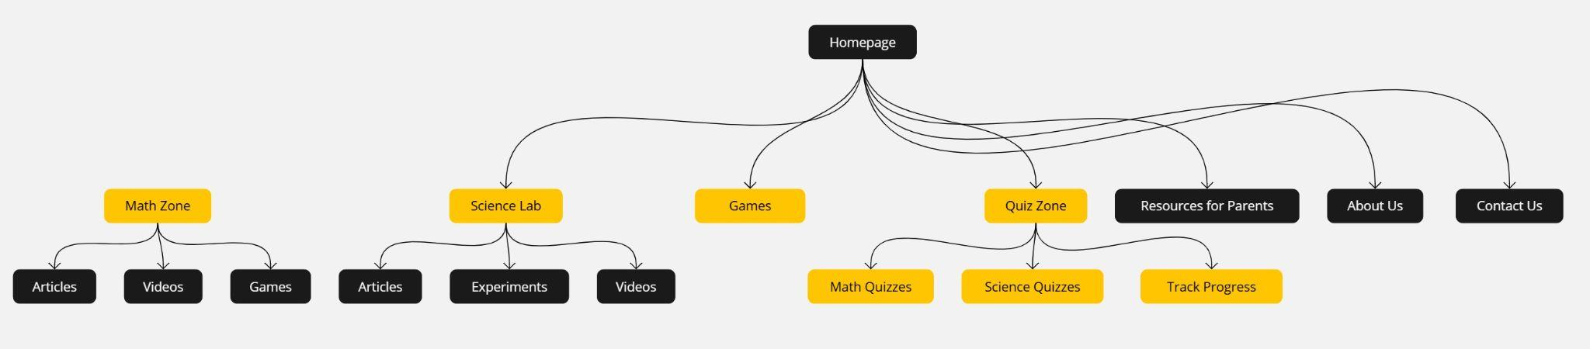

#### **f. Wireframes**

1.Homepage:

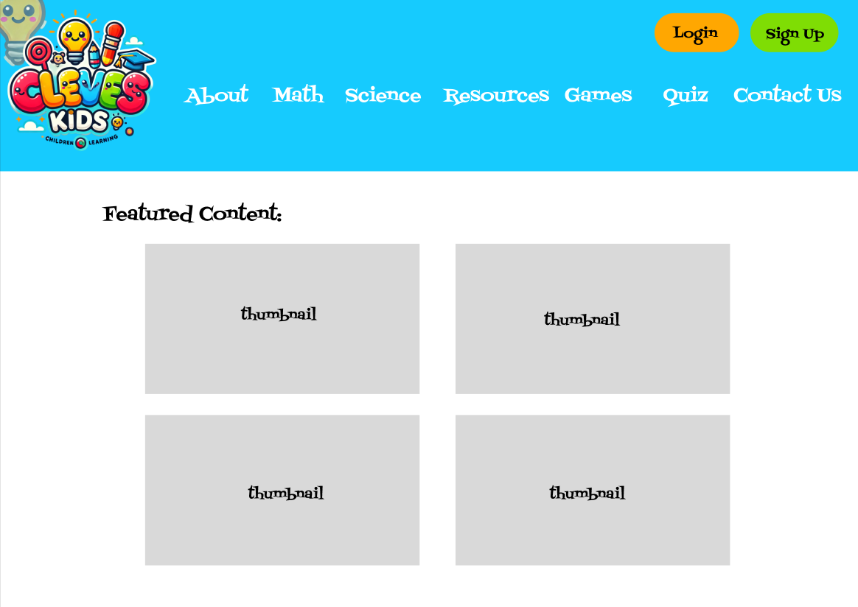

2. About page:

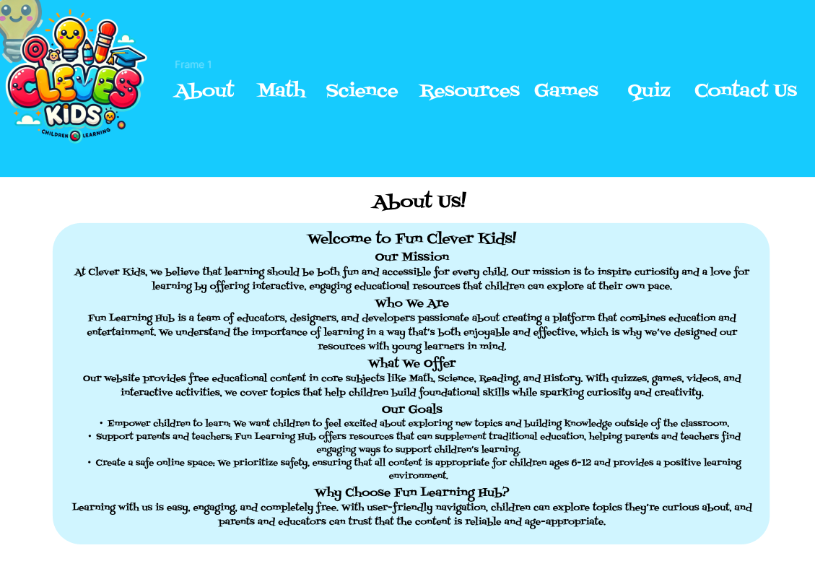

3. Math page:

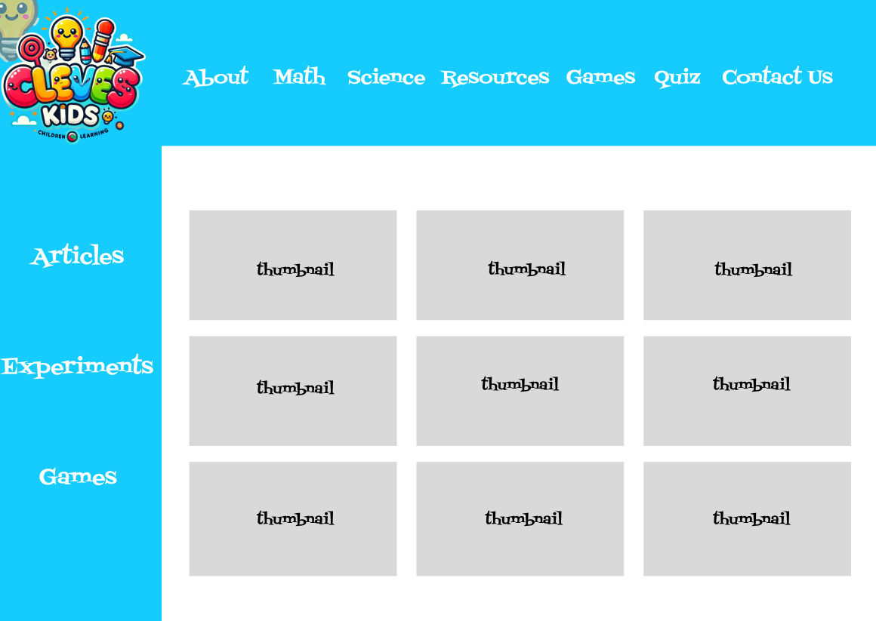

4. Science page:



5. Resources page:

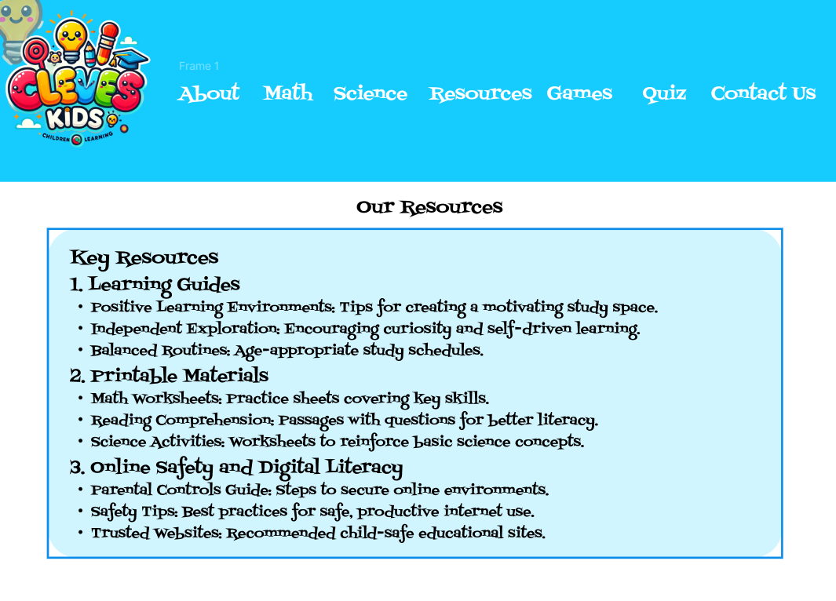

6. Quiz page:

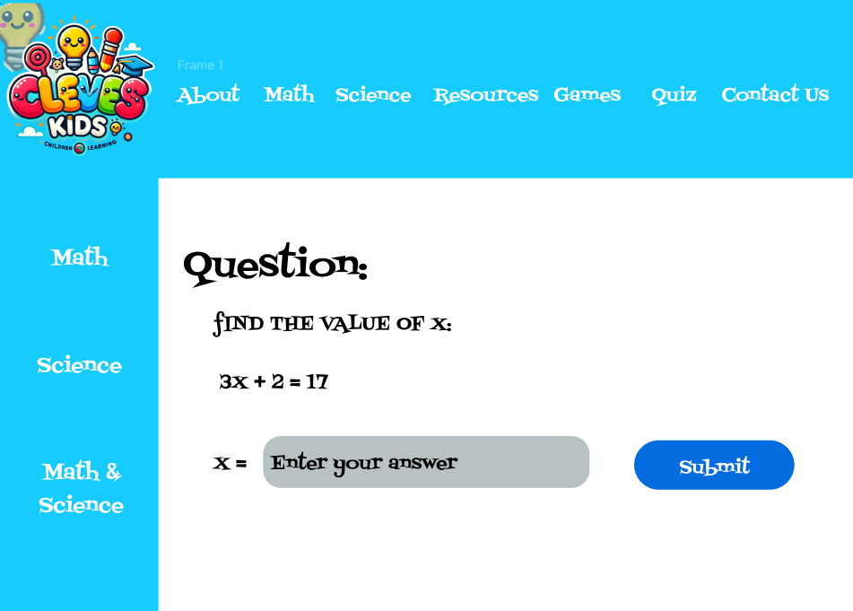

7. Contact Us page:

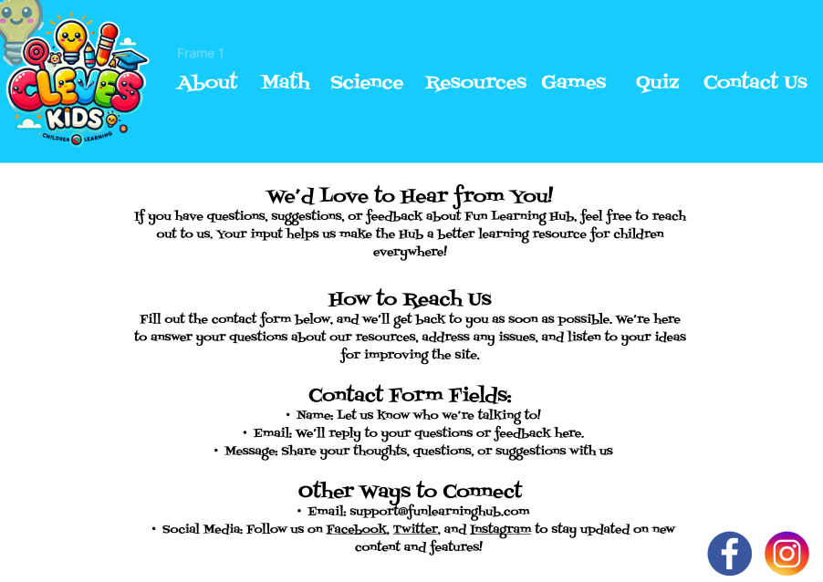

**Website design:**

**[A] Use Gestalt Web Design Principles to describe how you will implement the following**

1. **Law of Prägnanz (Simplicity):** Keep the layouts clean and simple with uncomplicated navigation menus and less visual clutter. For example, the homepage can have a central image or banner that shows what the site is about without too much information.
2. **Closure (Link Elements to Form Patterns):** Use familiar shapes or icons to connect related resources. On the Math page, for example, use puzzle-piece icons for topics like "Addition" and "Subtraction." Even if the shapes aren’t fully closed, users will still see them as a group.
3. **Symmetry and Order:** Use balanced, symmetrical layouts to help users easily understand content. For example, a grid layout on the Games page helps users quickly find what they're looking for.
4. **Figure/Ground (Contrast):** Use contrasting colors to make content stand out. For instance, a light background with dark text and colorful buttons highlights quizzes or games.
5. **Uniform Connectedness (Consistent Styling):** Maintain a consistent look with colors and fonts across all pages. For example, all buttons on the Games page should look the same so users recognize them as interactive.
6. **Common Region (Group Related Items):** Group related resources in distinct sections. For instance, on the Resources page, a bordered area can separate printable worksheets from other resources.
7. **Proximity (Space and Grouping):** Place related items close together. On the Quizzes page, similar quizzes are near each other, while unrelated items are spaced apart to avoid confusion.
8. **Continuation (Flow and Navigation):** Design layouts that guide users naturally from one section to the next. For example, a clear flow between quizzes and games encourages exploration.
9. **Common Fate (Consistent Animations):** Use similar animations or effects across the site, like all buttons slightly enlarging on hover, signaling that they’re clickable.
10. **Parallelism (Align Elements in Parallel):** Display lists or collections in a parallel structure. On the Games page, games can be shown in parallel columns, indicating they’re equally important.
11. **Similarity (Grouping by Style):** Use similar colors and styles to connect related content. Math-related items could have one color scheme, while science content has another, making it easier to identify sections.
12. **Past Experience (Use Familiar Icons):** Include familiar symbols, like a book for reading or a calculator for math, so users instantly recognize each section based on common educational website icons.

**[B] Deployment of other design concepts**

### **1. Screen Resolution**

* **Approach**: The site will be optimized for common screen resolutions, especially for tablets and smaller laptop screens, since children in the 6-12 age group often access educational websites on family tablets or shared laptops. It will be responsive across a range of resolutions (1280x720, 1920x1080) and adaptive for mobile devices to ensure readability and easy navigation on all devices.

### **2. Color Palette**

* **Color Palette Selection**: I will use Adobe Color Wheel CC to create a palette that’s bright, playful, and visually appealing to children. I’ll aim for a balance of vibrant primary colors that appeal to young users and maintain sufficient contrast for readability. After selecting the colors, 

### **3. Minimum Contrast for Accessibility**

* **Contrast Ratio**: To make sure our website is easy to read for kids with visual impairments, we’ll use a minimum contrast ratio of 4.5:1 for all text. This means we’ll stick to high-contrast color combinations, like dark text on a light background, especially in key areas. We’ll also ensure that icons and navigation elements are easy to see, improving accessibility for everyone.

### **4. Front-End Development Technologies**

* **Technologies**I will also be using **HTML5, CSS3**, and **JavaScript** to make the front-end user-friendly and interactive. We also make sure that the design will look good on all devices by applying **Bootstrap**. Possibly, we can use **jQuery** to make some tasks in JavaScript easier. These technologies ensure the website is fast-loaded and works well on different platforms

### **5. Content Management Systems (CMS)**

* **CMS**: WordPress or Drupal for our content management system. Both are flexible with many plugins available. They can easily take on a quiz, manage user accounts, and update content. WordPress is very appealing because it is user-friendly, so managing videos, articles, and quizzes will be much easier.

### **6. Back-End Development Technologies**

* **Technologies**: The back end will likely use **Node.js** and **Express** due to their scalability and ability to handle asynchronous requests (e.g., user progress tracking and quizzes). **MongoDB** can be used for database storage, providing flexibility for dynamic content storage, including quiz results and user interactions.

### **7. Metrics for Measuring Website Performance**

* **Metrics**: Key metrics to measure website performance will include:
  + **Page Load Time**: Faster load times improve the experience, especially important for young users with limited patience.
  + **Bounce Rate**: Low bounce rates will indicate effective user engagement.
  + **Average Session Duration**: Shows how long children stay engaged with the content.
  + **Conversion Rate**: Measures how many users register for accounts.
  + **Completion Rate of Quizzes/Games**: Indicates user interaction with learning materials.
  + **Error Rate**: Tracks any broken links or loading errors, ensuring smooth navigation.

### **8. HTML5 Page Structure for Each Page**

**HTML5 Structure**: Each page will follow a consistent HTML5 structure:  
  
<!DOCTYPE html>

<html lang="en">

<head>

<title>Page Title | Clever Kids</title>

<link rel="stylesheet" href="styles.css">

<script src="script.js"></script>

</head>

<body>

<header>

<nav>

<!-- Navigation Menu (Math Zone, Science lab, etc.) -->

</nav>

<h1>Clever Kids</h1>

</header>

<main>

<section>

<!-- Main content, dynamically changing by page -->

</section>

<aside>

<!-- Sidebar content if applicable, like related articles -->

</aside>

</main>

<footer>

<p>&copy; 2024 Clever Kids. All rights reserved.</p>

<nav>

<!-- Footer Navigation (About Us, Contact, etc.) -->

</nav>

</footer>

</body>

</html>